** STREAM:**

**Optimizing Mental Health**

we’d greatly appreciate your use of this qr code to record attendance for this HRSA funded program

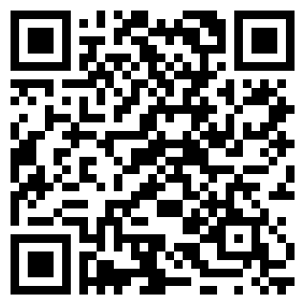

1. **Physician Mental Health & Distress**

PARTNER ACTIVITY: discussion

1. **Optimizing Mental Health**

**INDIVIDUAL ACTIVITY: Self Compassion**

Think about when you are likely to experience negative self talk (when you make a mistake, when you don’t accomplish something). What kinds of things do you often tell yourself?

Write down how you can re-frame your self-talk from a lens of self-compassion

**INDIVIDUAL ACTIVITY: Intentional Gratitude**

* + What surprised me today?
  + What touched my heart today?
  + What inspired me today?

PARTNER ACTIVITY: Culture of Gratitude

SMALL GROUP ACTIVITY: Culture of Caring

PARTNER ACTIVITY: Relational Pauses

**3. Design a Well-Being Plan**

1. **Self-reflect and identify your individual signals of distress**

* Examples: irritability, temper flares, withdrawal or isolation from others, anxiety, depression, sleep changes, Others? WHAT ARE YOURS?

1. **Design your well-being plan**
2. Strategies when you note increasing signals of distress

b) Strategies for everyday to optimize and maintain mental health

c) Identify at least 1 goal that you want to commit to achieving

**3) Who can you identify as your Accountability Buddy?**

GROUP ACTIVITY: anything surprising or difficult?

Thank You

We’re so glad you could be part of this program with us today. Thank you for your participation!

Please help us out by completing this 6 question evaluation today! We’d love your input re:

Content relevancy, DEI incorporation, interactiveness of session, facilitator effectiveness, likelihood to recommend, and an open ended section for anything you’d like to note.

You’ll receive a follow up survey in two weeks. We’d love your feedback!

Brief Eval

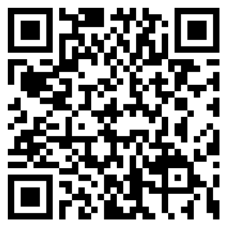

Extra Resources Available to You

STREAM Resource Library

There are extra STREAM resources and activities available for your use on our site as well.  We have more videos, worksheets, and other links that you may find beneficial.  Check them out here:

note: these materials are available for anyone with a STREAM account

Resources

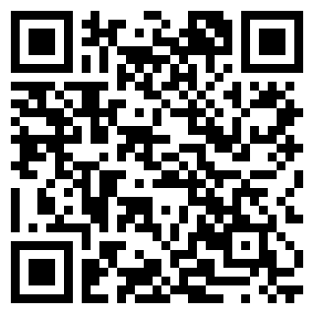

STREAM App

Download our app, available for free

Apple: Android:

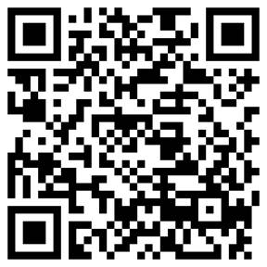 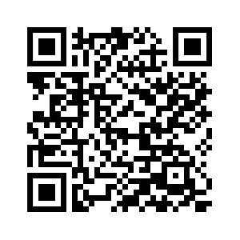

Features

-Buddy chat (anonymous capability)

-Goal setting and tracking

-Journaling

-Links to extra STREAM resources on the app

-Opportunity to provide feedback for STREAM programming

Follow us on Twitter: STREAM@elms